Name | Shiven Saxena
Student ID | 34997407
Studio Session | 17

Part A: URL of the Visualisation

Paste your visualisation URL in the empty space below.
Tip: Test your URL in incognito mode to ensure it is a working URL

https://ssax0009-ctrl.github.io/DV2_FIT3179/

Part B: Domain Description

Describe your domain chosen for DV II
- The domain for this visualisation is: Australian women’s healthcare, and how hospital care for hysterectomy and endometriosis is affected by state, local hospital network, funding sector and age.
- The users are health-service planners and women’s health advocates, who understand complex terms such as median wait, LHN, SA3, age-standardised rate, SES group and suppressed data.
- Their workflow is constrained by public-only waiting times, waits and rates from different years, and withheld values that must not be read as short waits.

Describe the Why and Who aspects of your DV II

Why
The goal is to survey how affordable and accessible Women’s health is through looking at the statistics of the two of the most common reasons for hospitalisations Endometriosis and Hysterectomy.

Who (in the perspective of Australians):
- Health Service Planners and Policy makers:
  - We analyse to the local level and show how this differs from the state level, integral for local governments to know how to “plan ahead”
- Women Health advocates:
  - Showing trends and how accessibility is improving over time, especially when different groups are in perspective

- General Women (especially those with Endometriosis or Hysterectomy):
  - Analyse the how accessibility for treatment and where is ready for them

Describe the “What” aspect of your DV II

Australian atlas of healthcare variation time series 2014–15 to 2021–22: Hysterectomy hospitalisations

Data name | Author | Use | Why?
Hysterectomy hospitalisations, 2014–15 to 2021–22 | AIHW Australian Atlas of Healthcare Variation (National Hospital Morbidity Database, ABS population estimates). Women 15+, age-standardised to the 2001 population. | State and SA3 rates, Indigenous status, remoteness and SES, private share (Figures 3–11) | Hysterectomy is a very common surgery and can be described as a benchmark for all surgeries, this data is comprehensive on locations, as well as sectors.
Elective surgery waiting times, 2024–25 | AIHW Australian hospital statistics, Table 4.7 for state medians, plus LHN files with coordinates | Figures 1–2 | Observing wait times shows us how accessible a procedure is
Endometriosis hospital procedures (PHE 357) | AIHW, 2026 supplementary tables | Admissions, urgency, age, sector (Figures 12–15) | Most of the data for endometriosis which is one of the most prevalent illness specific to women
Boundaries | ABS ASGS Edition 3 (SA3); geoBoundaries gbOpen (state outlines) | Maps | For making maps

Some notes on the Creation Process:
- Missing Data was often an issue, especially when 2 graphs are complementary, so I made the difficult decision to suppress both in order to prevent misleading information
- Some data was not all in the same place, such as coordinates, so I had to find that separately.
- One of the biggest problems was quality data, as there were not many actual data providers. Weighing the odds, I decided to use old data 2021 - 2022 that is credible over non credible data that is relevant.
- Figure 1 and 2

Describe the “How” aspect of your DV II

Figure | Idiom | Reasoning
1 | Choropleth map | Help show density of state, and can be used to compare for outliers (figure 2)
2 | Proportional symbol map | Shows the movement of densities (closer to the coast the more hospitals for example) help compare with figure 1
3 | Ridgeline graph | Shows the distribution of women for hospitalisations, allows us to see how location affects the average for each state (exposing lying with state averages)
4 | Interval plot | Similar to ridgeline, but further shows exemplifies the idea of the outliers.
5 | Dot Map | Shows that variation is spread geographically and what regions are most sparse
6 | Radial chart | Combines two factors at once: remoteness by colour and SES by slice. It demonstrates that the highest rates are not in the most remote areas.
7 | Dumbbell | Two groups (First nation and Others) per state with the gap drawn, so the direction of the difference is the first thing seen. Helps us compare if First Nation people are getting the care they deserve
8 | Waffle | One square equals 1%, so private share is counted, not estimated. An easy visual to see how private hospitals dominate over public hospitals.
9 | Slope chart | Compares 2 main years, allows us to see whether the surgery admissions increase or decrease.
10 | Tile-grid map with sparklines | Equal-size tiles stop Tasmania, the ACT and the NT from vanishing on a real map. Sparklines add the shape between the endpoints. A fun intuitive map that shows rates per state.
11 | Heatmap | Another usage of distribution, but here we compare state and time. Allows us to see a projection of how hysterectomy records are falling
12 | Time series | Shows growth/decline of endometriosis rate.
13 | waterfall | Demonstrates ideas such as medical urgency as well as assisting the time series
14 | Parallel Plot | Ten procedures are muted for context. Two (laparoscopic excision and cystoscopy) are emphasised to show different age peaks and how age plays a role on surgery given and accessibility.

Special Features:
Used a button for glossary for ease of use.

AI Declaration (also on visualisation):
AI was used in this assignment with LLMs such as Claude, Copilot, Chatgpt and Gemini to help debug code, ease of code format and structuring as well as giving advice.

Part C: Sketch
A URL to a PDF document with an image of your sketch on your GitHub account.
https://github.com/ssax0009-ctrl/DV2_FIT3179/blob/main/sketch.pdf

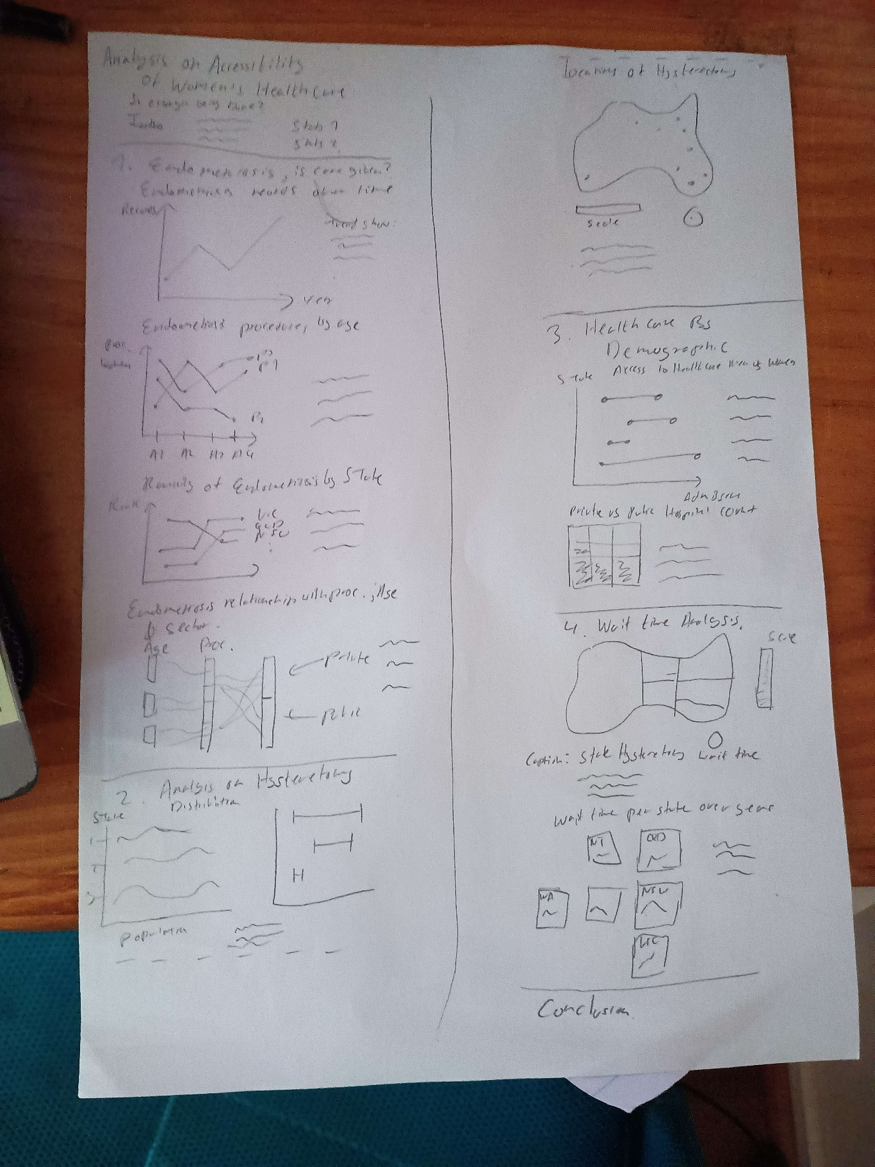

Part D: Full-size screenshot of your DV II
Paste a full-size screenshot of your DV II assignment from the URL here

